 **SUBMITTED OCTOBER 18, 2023**

**Request for School Board Reconsideration of Library Media Materials**

**Author: Elana Arnold**

**Title: Damsel**

**Publisher: ‎**Balzer + Bray (October 2, 2018) Vintage; Reprint edition (June 8, 2004)

**Request initiated by: (October 18, 2023)**

**Telephone:   
  
Address:**

**City:**

**Zip:**

1. To what in the book/material do you object: (Please be specific; cite pages, frames of films, dialogues, etc.)?

X Sexually Explicit- graphic descriptions of sex: two rape scenes, one bestiality scene, unwelcome fondling, kissing, touching  
X Language: mild; stupid terms for penises (“yard” and “horn”)  
X Violence: high; sexual assault, descriptive animal cruelty, degradation

See attached detailed references.

1. Where did you first learn of this item?   
     
   I first heard about this book when I was doing research about issues in the Manatee County schools. I was looking for opportunities to help improve the school culture and academics. I reviewed a number of the books that were on the lists of books being banned by school districts throughout Florida and in other states. I was horrified to see the inappropriate materials that are being made available to students – **our** students.   
     
   I decided to become involved with the School Board Elections as a starting point. The candidates in the 2022 Manatee County School Board Elections had platforms that promised to address some of these shortcomings. I also attended some meetings with the Media Committee as they were grappling with the legislative changes that were being made in Florida, waiting for guidance on how to address challenges of some of the books that we had flagged. At these meetings I found out that materials in the Library are violating Florida Law with regard to the protection of the students from pornographic sexual materials. In addition, I take issue with books that promote immorality, drug abuse, sexual confusion, suicide, anti-America sentiments, racism, activism etc.   
     
   I am not challenging the freedom to read but wish to ensure that young people not be subject to topics that are not appropriate for their level of maturity or mental health. Public libraries and book stores are available for adults to access whatever materials that they may choose. Our schools should take the high road when it comes to our young people.  
     
   Oh -- Just a reminder, the district policy:

* Require book selections to be free of pornography and prohibited materials harmful to minors, suited to student needs, and appropriate for the grade level and age group;
* Require consultation of reputable, professionally recognized sources and school community stakeholders for each selection;
* Provide for library media center collections based on reader interest, support of state academic standards and aligned curriculum, and the academic needs of students and faculty; and
* Provide for the regular removal or discontinuance of books based on factors specified in the bill, including those removed because of an objection by a parent or resident of the county.

1. Have you read the book in its entirety?  
     
   No but I did extensive research on the book including the overall simplistic plot as well as reading a number of book reviews.. I particularly enjoyed this frank review by a secondary school librarian. If you read it you may also agree.  
     
   SUMMARY OF DAMSEL  
   When a king dies, his son must venture into the world, slay a dragon, and rescue a damsel. Only then can the prince prove himself worthy of becoming the new king. When Ama wakes in Prince Emory’s arms, she has no memory of her life before. Prince Emory tells her he has rescued her from a dragon, and now, she is destined to become his wife and queen.

#### REVIEW OF DAMSEL I’m not really sure how to review this, but I’m going to give it a try. This is one weird little book. It’s like a bad car accident that you can’t look away from. It made me so mad, but I read nearly all of it in one sitting. I can’t really say I liked it, but I can’t say I hated it, either.

My biggest concern is that this is marketed as YA. Publishers label a book as YA when they market it to readers aged 12-18, but we all know that YA isn’t for every 12-year old.   
  
In *Damsel*, the characters themselves are young adults. Ama is never given a specific age, but Prince Emory is nineteen. Rape, misogyny, and animal cruelty may appear in other YA books, but as an avid and regular reader of YA books, not to mention a secondary school librarian, this one just does not feel like YA to me.

I liked the ending, but the “twist”–if it can even be called that–is super-predictable. Just read the summary and think about it for five minutes. You’ll probably guess it correctly. I’m not sure if it is even supposed to be a twist since the whole story is dripping with hints.

Because it is marketed as YA and received two starred reviews (and now, a Printz Honor), I worry that school librarians will purchase this title without knowing what they are buying. School librarians, you really should read this before you buy it for your library, but in case you don’t read it, here’s a guide to what you’ll get (some spoilers here):

* rape–one digital penetration and one forced “hand job”
* lots of awkward and unwelcome kissing, touching, and breast-squeezing
* lewd staring by several male characters
* rape culture, constant threat of rape
* descriptive and repeated animal cruelty and threat of animal cruelty
* multiple references to Emory’s penis as “yard” and “horn.” It gets old quickly.
* story of a former queen’s self-harm and suicide
* it is well-known that Emory has and keeps many female conquests, even as he is engaged to Ama
* a brutal (but oh-so-satisfying) murder
* one disgusting, cringe-worthy bestiality scene. Prince Emory “slays” the dragon by having sex with its wounded armpit. I wish I were joking.

So what is to be gained by purchasing this title for your library? Well, I’m sure there is someone in your school who will love this book. It has plenty of fodder for discussion, even if that discussion may be fueled by contempt for the book. Book clubs could have a heyday with it if minds stay open and members don’t just shut down and refuse to read it (as sometimes happens in book clubs).

**THEMES:** feminism, power, control

**THE BOTTOM LINE:** *Damsel* was interesting enough for me to read in one sitting, but I have no idea what audience this should be for. I think more people–teens and adults alike–will hate this book than love it. At the same time, I’d love to discuss this in a university class or a book club. If I were giving an award for the weirdest book of 2018, this would be the hands-down winner.

**STATUS IN MY LIBRARY:** I don’t plan to get this one. While there may be readers who find value, my budget is limited, and there are other titles I’ll choose first.

#### MATURE CONTENT

* Language: mild; stupid terms for penises (“yard” and “horn”–LOL)
* Sexuality: high; two rape scenes, one bestiality scene, unwelcome fondling, kissing, touching
* Violence: high; sexual assault, descriptive animal cruelty, degradation

### Is there any additional information you would like us to consider in our evaluation? What would you like the final outcome to be for this library media item or items? This book is a bad takeoff of a fairy tale with violence and a nice dose of tawdry sex. I think that we can do better than this for our young people. It certainly does not belong in a school.

**Remove from all Manatee School District Schools and Media Centers and disallow future purchases– see below**

### Bay Shore High School

### Braden River High School

### Manatee High School

### Parrish High School

### Southeast High School Media Cetner

February 15, 2023

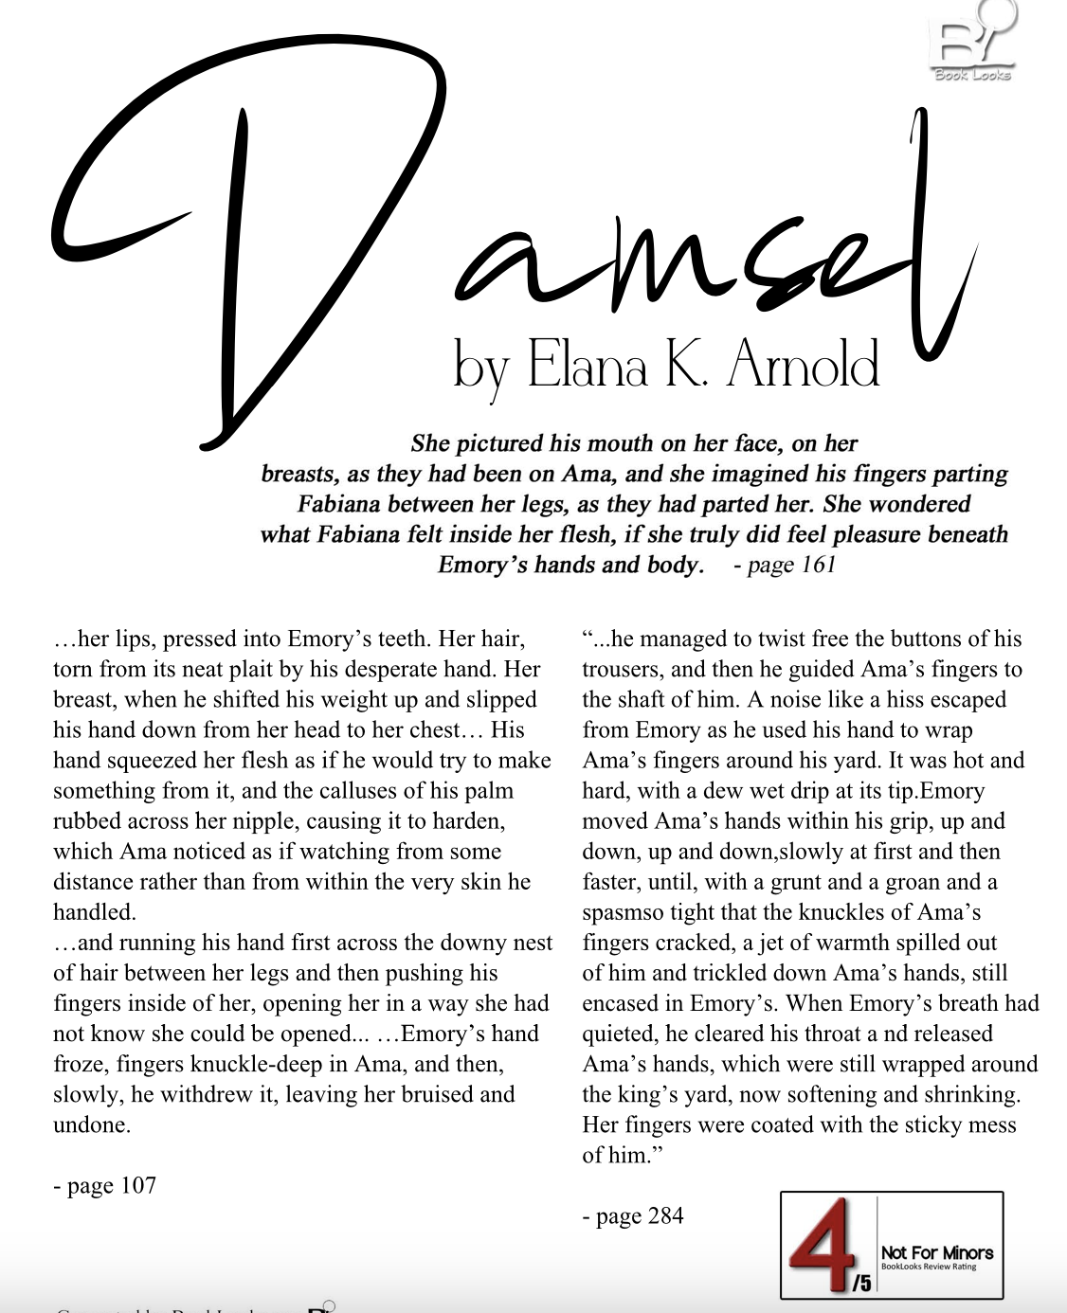

**DAMSEL**

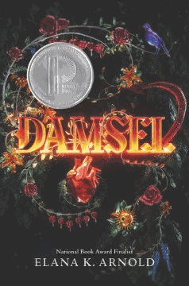

*Young Adult*

**By Elana Arnold**

ISBN: 978-0-06-274232-2

**Summary of Concerns:**

This book contains explicit sexual activities; sexual battery; and sexual nudity; and infrequent profanity.

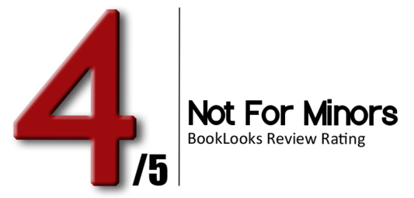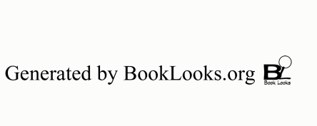

|  |  |
| --- | --- |
| **Page** | **Content** |
| 17 | Then, knowing the dragon was watching, he unbuttoned the front of his trousers, freed his yard, and pissed a steaming stream right there, at the top of the cliff, marking it as his own. |
| 56 | Reynard watched with disinterested curiosity as Emory rubbed Ama dry with the coarse wool blanket; he started with her arms, rubbed her breasts, the hard pink nubs of her nipples, her stomach, her buttocks, the fire red hair between her legs, her legs themselves. |
| 60 | “Ridiculous, the size of babies when they slip from their mother’s slits.” |
| 107 | She raised herself up onto her elbows, and would have sat fully erect but for Emory’s insistent hand on her shoulder, pinning her there, and then his insistent mouth slashing down across her own. His mouth was hot and wet and open and tasted of the evening’s wine and meat. Underneath the weight of him- his mouth, first, and then his chest across hers, pressing Ama back into the mattress- Ama felt breathless and trapped, as if she had been submerged underwater.  ...The rest of her became part of the landscape of the room- her lips, pressed into Emory’s teeth. Her hair, torn from its neat plait by his desperate hand. Her breast, when he shifted his weight up and slipped his hand down from her head to her chest, pulling apart the ribbons of her chemise, spreading open the cloth, and finding her bare skin beneath. His hand squeezed her flesh as if he would try to make something from it, and the calluses of his palm rubbed across her nipple, causing it to harden, which Ama noticed as if watching from some distance rather than from within the very skin he handled.  But when Emory tugged up at the hem of Ama’s shift, bunching the fabric at her waist and running his hand first across the downy nest of hair between her legs and then pushing his fingers inside of her, opening her in a way she had not know she could be opened, Sorrow growled once more. ...Emory’s hand froze, fingers knuckle-deep in Ama, and then, slowly, he withdrew it, leaving her bruised and undone. Emory cleared his throat, lifted himself from the bed, and arranged his yard, which stood in his trousers, hard and demanding. |
| 161 | She pictured his mouth on her face, on her breasts, as they had been on Ama, and she imagined his fingers parting Fabiana between her legs, as they had parted her. She wondered what Fabiana felt inside her flesh, if she truly did feel pleasure beneath Emory’s hands and body. |
| 166 | “...It can be a soft lump of warm dough, a handful of wrinkles and weight. And then it becomes a great thick horn, like the well-cooked leg of a turkey. And then, down betwixt my legs, it feels like...well, a key, perhaps, or a poker to a fire. It stirs me up. It takes my apart. It makes me feel myself like a warm, moist dough.” |
| 167 | “But as you seem to take pleasure in that which I most likely just endure, I wanted to let you know that it would not be against my wishes if you continued to...take visits from the king.” ...”Lady,” she said finally, “you are greatly mistaken if you think it matters one whit whether I find pleasure or no pain with my king’s yard, or, for that matter, |





|  |  |
| --- | --- |
| **Page** | **Content** |
|  | whether or not you do. What matters, only, is my king’s pleasure. You, and I, and whichever other girls take his fancy, we are all servants to that.” ...”if you cannot find pleasure with my king, I suggest you at least find a way to appear to do so. Otherwise, you risk his wrath. And a man’s wrath can be mightier by far than his yard.” |
| 222 | If, she thought at the end of each night, as Emory walked her to the door of her chamber, as he kissed her face and her mouth and her throat, as he kneaded the mounds of her breasts through the velvet and satin of her gowns (not troubled, it seemed, by her waning figure), as he pushed her up against the door, grinding his yard into her stomach. |
| 250 | Ama, as ever, stood very still as Emory breathed, ht and moist, against her ear, his hands skimming her shoulders, down her arms, across her waist, and back up to her breasts, which he took in both his hands and squeezed. “Soon, I will be the one to warm you, and from the inside,” he promised, before taking her bottom lip in his teeth and pulling it into his mouth, sucking it there hard enough to leave it swollen. |
| 283 | Emory’s hands still trapped hers, and he held them in his lap, and she felt beneath the tangle of their hands the rising of the king’s yard. |
| 284 | “We are but three days from our wedding, Ama,” Emory murmured. “I am your secret-keeper, and soon to be your husband. Surely you would not deny me a taste of your sweetness, now, this day, after the favors I have given you?” He didn’t wait for an answer, and still he did not free Ama’s hands. Holding them both in one of his, he managed to twist free the buttons of his trousers, and then he guided Ama’s fingers to the shaft of him.  A noise like a hiss escaped from Emory as he used his hand to wrap Ama’s fingers around his yard. It was hot and hard, with a dew-wet drip at its tip. Emory moved Ama’s hands within his grip, up and down, up and down, slowly at first and then faster, until, with a grunt and a groan and a spasm so tight that the knuckles of Ama’s fingers cracked, a jet of warmth spilled out of him and trickled down Ama’s hands, still encased in Emory’s.  A moment passed, during which the only sounds were Emory’s labored gasps and the intermittent squeaking of carriage wheels. When Emory’s breath had quieted, he cleared his throat and released Ama’s hands, which were still wrapped around the king’s yard, now softening and shrinking.  Her fingers were coated with the sticky mess of him. |
| 305 | “You stabbed me with your steel,” Ama said. “I did. My second weapon. I found the unprotected flesh beneath your arm. I pierced you good, I did.” Ama remembered the blade going in, the surprise of it. She saw herself biting at the wound, desperate to extract the metal from within her flesh. She felt her teeth connect with the sword’s shaft, she remembered how it felt to pull it out, the rush and gush of blood that came with it. “And then,” said Ama. “Yes,” Emory said. “It takes three weapons to conquer a dragon and free a damsel. My brain. My steel. And my yard.” “Your yard,” Ama said. |

|  |  |
| --- | --- |
| **Page** | **Content** |
|  | “You should thank me,” Emory repeated. “You- the dragon- managed to extract the steel. The dragon lay and bled, but I knew it would not be long before it rose again, and my sword was gone, so the next time I attacked, I would be done for. There was nothing to lose by trying. And Mother had told me that it takes three weapons to slay a dragon. My yard, I have with me, always.  “Of course,” Emory continued, “a dragon is not female in the same ways as a woman...They do not mate or birth. One a generation, that is all. One dragon, one damsel. You were my destiny, Ama. I had to take you. I went to the dragon’s lair to find a damsel. I would leave with one.”  “You...improvised,” Ama said, remembering. She had lain bleeding on the stone floor of her lair... ...And here came Emory, loosening the buckle of his belt, freeing the horn of him, and entering the bloody tear he had ripped beneath her arm. |

**Profanity Count**  Shit 1

page4image3361858896page4image3361859200