 **SUBMITTED NOVEMBER 7, 2023**

**Request for School Board Reconsideration of Library Media Materials**

**Author: Alice Sebold**

**Title: The Almost Moon**

**Publisher: ‎** Little, Brown and Company (October 16, 2007)

**Request initiated by: (November 7, 2023)**

**Telephone:   
  
Address:**

**City:**

**Zip:**

1. To what in the book/material do you object: (Please be specific; cite pages, frames of films, dialogues, etc.)?

X Sexually Explicit including minors with adults, references to pornography  
X Graphic Violence / Murder, grotesque descriptions of dealing with the corpse  
X Depression and Mental Illness and Abusive behavior  
X Suicide and Contemplation of Suicide  
X Profanity (see list at end)  
X Alcohol and Drug Use  
X Anti-religious references

See attached detailed references.

1. Where did you first learn of this item?   
     
   I first heard about this book when I was doing research about issues in the Manatee County schools. I was looking for opportunities to help improve the school culture and academics. I reviewed a number of the books that were on the lists of books being banned by school districts throughout Florida and in other states. I was horrified to see the inappropriate materials that are being made available to students – **our** students.   
     
   I decided to become involved with the School Board Elections as a starting point. The candidates in the 2022 Manatee County School Board Elections had platforms that promised to address some of these shortcomings. I also attended some meetings with the Media Committee as they were grappling with the legislative changes that were being made in Florida, waiting for guidance on how to address challenges of some of the books that we had flagged. At these meetings I found out that materials in the Library are violating Florida Law with regard to the protection of the students from pornographic sexual materials. In addition, I take issue with books that promote immorality, drug abuse, sexual confusion, suicide, anti-America sentiments, racism, activism etc.   
     
   I am not challenging the freedom to read but wish to ensure that young people not be subject to topics that are not appropriate for their level of maturity or mental health. Public libraries and book stores are available for adults to access whatever materials that they may choose. Our schools should take the high road when it comes to our young people.  
     
   Oh -- Just a reminder, the district policy:

* Require book selections to be free of pornography and prohibited materials harmful to minors, suited to student needs, and appropriate for the grade level and age group;
* Require consultation of reputable, professionally recognized sources and school community stakeholders for each selection;
* Provide for library media center collections based on reader interest, support of state academic standards and aligned curriculum, and the academic needs of students and faculty; and
* Provide for the regular removal or discontinuance of books based on factors specified in the bill, including those removed because of an objection by a parent or resident of the county.

1. Have you read the book in its entirety?

No – I have only read summaries and commentaries about this book

**Plot Summary**Alice Sebold’s second novel, The Almost Moon (2007), is the follow-up to her well-received first novel, The Lovely Bones, which was adapted for film by director Peter Jackson. The Almost Moon follows it in its depiction of terror, bodily trauma, violence, and mental illness. The novel takes place over a fluid twenty-four-hour period interspersed with memories and flashbacks after the main character, Helen Knightly, murders her mother. Although critical reviews were mixed to negative, many critics praise Sebold’s style and ability to face challenging subjects head-on.  
  
Helen Knightly murders her eighty-eight-year-old mother, Clair, by suffocating her with a towel after she goes to bathe her and is disgusted by the scent of her waste. Her mother lives her life as an agoraphobic, and as she gets older, develops dementia. Helen is a nude model for art students, a mother of two daughters, and divorced. She lives a life she perceives as normal until her awareness of familial dysfunction seeps in from the outside. Sebold writes from Helen’s perspective; Helen could be classified as an anti-hero and an unreliable narrator. Though the novel unfolds over the twenty-four-hours after the murder, it is mostly made up of flashbacks to her childhood and her life before the murder.  
  
She confesses that, although a spontaneous act, the murder is the fulfillment of a lifelong desire. She has always desired to kill her mother, and this moment is a culmination of those feelings. She blames her mother for slowly destroying her life, both directly and emotionally.

The first section focuses on Helen’s experience with her mother’s body: having to take her clothes off to bathe her. This transitions to blunt and grotesque descriptions of dealing with her corpse. As she deals with the aftermath of the murder, she brings her ex-husband, Jake, into the mix as a co-conspirator when she calls him.  
  
The next section recalls posing for young art students. This establishes the link between the body, memory, and trauma. This also ties into her mother’s criticism of her body throughout her childhood. As she goes about covering up the murder, certain incidents trigger a flashback. For example, when she bumps her head getting into the car, she is reminded of an incident where her mother dropped Helen’s grandson on his head.

After bringing her mother’s body down to the cellar, she reflects on sleeping with her best friend Natalie’s son Hamish. He is much younger than she. Natalie is extremely angry with Helen after she finds out. Helen has known Hamish from birth and participated in his upbringing, giving the relationship an incestuous tone.

The flashbacks reveal her family as dysfunctional and troubled. Triggered by seeing her father’s gun collection, Helen recalls her father’s suicide. He suffers from mental illness and a tormented past. She also reflects on her mother’s relationship with her father, Daniel. He suffers from depression. Helen concludes that her mother’s experience with mental illness draws him to her and is, possibly, what made them stay together for so long. Although living a perceptively normal childhood, the dysfunction of Helen’s parents leads to her issues in adulthood.  
  
The depiction of Helen’s mother is somewhat autobiographical, comparable to the depiction in Sebold’s memoir, Lucky. Helen’s mother is cruel and loveless to Helen. She constantly criticizes her, especially her appearance, and is difficult to please. Despite this, Helen sacrifices her average life to care for her mother. Claiming to hate her mother, she questions why she chose to care for her in the first place. She concludes that her failed personal life is probably what ties her to her mother, but she cannot settle on a direct reason for sticking around. When her mother develops agoraphobia, she acts strangely when leaving the house, covering herself in blankets and moaning. She hates the chaos of society. Helen, in contrast, hates the confines of her life and the barriers keeping her trapped. She wants to escape.

Helen first meets her ex-husband, Jake, while he’s an art student and she’s teaching. This sets up a power dynamic that seeps into their relationship. Helen’s daughters are exact opposites of each other. Reflecting some of her own mother, Helen questions if she is a good mother to them. She left them after the divorce and lacks affection. Her ex-husband also questions her ability as a mother. He understands leaving him, but leaving their daughters behind is unforgivable in his eyes.

The close of the novel leaves Helen with a small chance for redemption. She chooses to face the consequences of her actions. She realizes that her daughters should not inherit the sins of their mother – as well as Helen’s mother – and facing judgment is her only option. She hopes to repair her relationships from the claustrophobic setting of a prison or mental institution, a link to her mother’s agoraphobia. The reader is left to question if Helen can be redeemed for killing her mother and if her own perspective of her life is sympathetic or unreliably skewed.  
  
**My Comments**  
This book deals with so many topics: depression, familial disfunction, suicide, drug and alcohol use, graphic sexual encounters etc. It does not seem that this book would be edifying for a teen and certainly examines some many difficult situations that are better left to an adult. Oh! And this Book is listed as an **ADULT** selection in the Manatee Public Library system. Why does it need to be in the School Library? The book violates the ban on allowing pornographic materials for minors.

*FS 847.012 2b(4), “A person may not knowingly sell, rent, or loan for monetary consideration to a minor (b) any book, pamphlet, magazine, printed matter however reproduced, or sound recording that contains any matter defined in s. 847.001, explicit and detailed verbal descriptions or narrative accounts of sexual excitement, or sexual conduct and that is harmful to minors."*

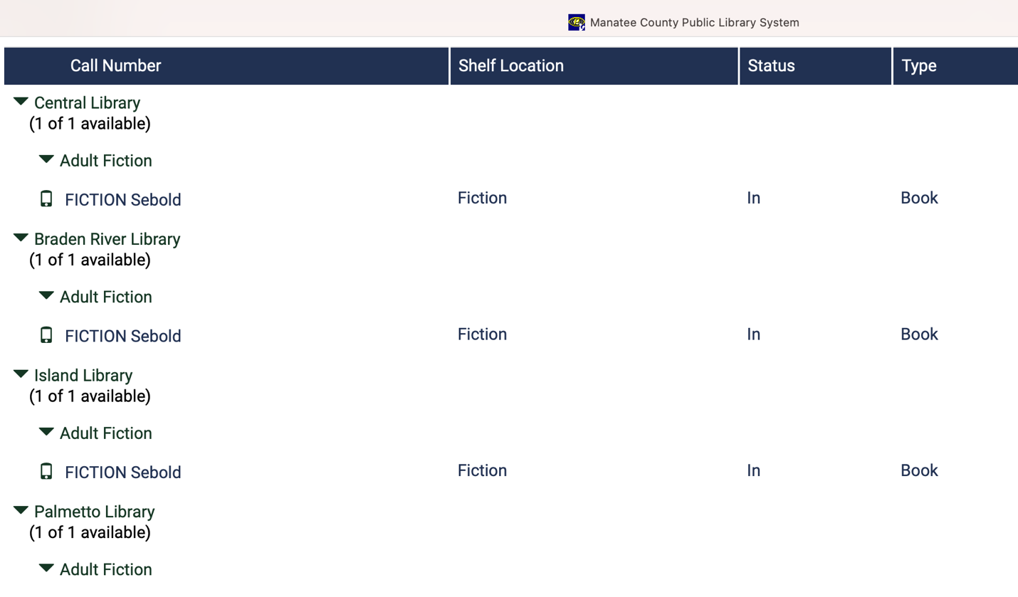

1. **Remove from all Manatee School District Schools and Media Centers and disallow future purchases– see below**

### Lakewood Ranch High School

### Braden River High School

February 15, 2023

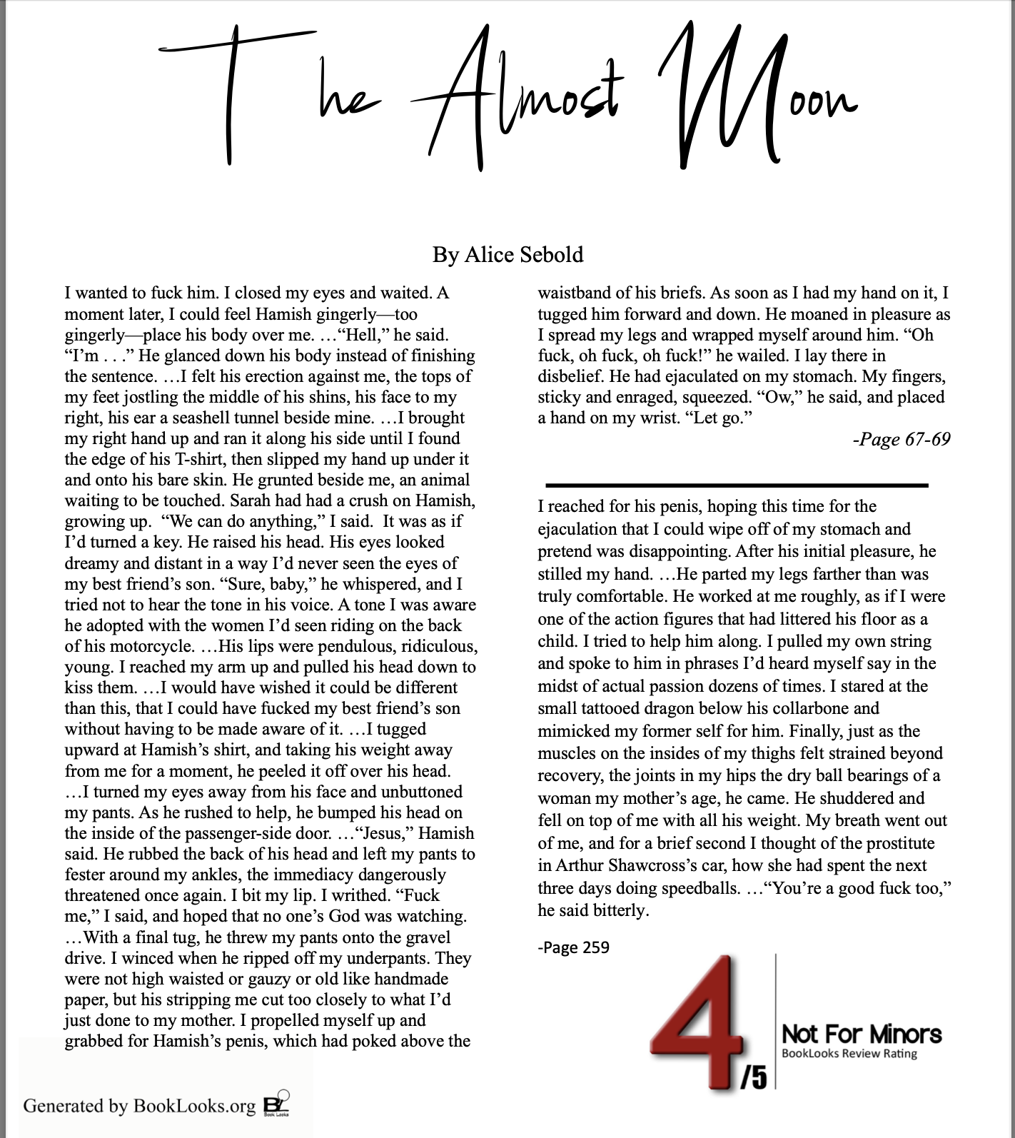

**THE ALMOST MOON**

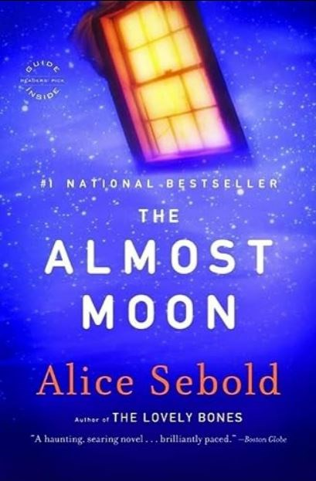

***Adult***

**By Alice Sebold**   
ISBN: 978-0-316-02283-5

**Book Summary:**

A woman recalls her life leading up to and after murdering her mother.

**Summary of Concerns:**

**This book contains obscene sexual activities; sexual nudity; self-harm involving suicide; reference to hate involving religion; alcohol use; and profanity.**



**Page** 2   
When I was young, my mother had railed against the Greek Orthodox church down the road, calling its parishioners, for no reason that made sense, “those stupid Holy-Rolling Poles.”

Page 23  
On the weekends he sat in his yard and drank beer.

Page 38  
“I want to fuck you,” Jake said.

Page 53  
I remembered turning around and seeing it, imagining the dulled platinum barrel, the scarred brown grip, and thinking of my father lifting it, loading it, raising it to his head.

Page 67   
Hamish crawled in but sat on the edge of the seat with the open door behind him. “I’m not sure what this is,” he said.  
“I’m cold,” I said. “I just want to feel your body on top of me.”  
I wanted to fuck him.

I closed my eyes and waited. A moment later, I could feel Hamish gingerly—too gingerly—place his body over me. He was bracing himself against the backseat and still resting most of his weight on the floor.  
“I don’t know what you want,” he said.

“I want all of you on me,” I said, opening my eyes.  
“Hell,” he said. “I’m . . .” He glanced down his body instead of finishing the sentence. “Just put your full weight on me,” I said. “It’s fine.”  
And then, within a moment, his body—all, what was it, 185, 190 pounds?—was laid out on top of me and pressing down. I felt his erection against me, the tops of my feet jostling the middle of his shins, his face to my right, his ear a seashell tunnel beside mine.  
...I brought my right hand up and ran it along his side until I found the edge of his T- shirt, then slipped my hand up under it and onto his bare skin. He grunted beside me, an animal waiting to be touched. Sarah had had a crush on Hamish, growing up.  
“We can do anything,” I said.  
It was as if I’d turned a key. He raised his head. His eyes looked dreamy and distant in a way I’d never seen the eyes of my best friend’s son.  
“Sure, baby,” he whispered, and I tried not to hear the tone in his voice. A tone I was aware he adopted with the women I’d seen riding on the back of his motorcycle. They wore ludicrous shorts while wrapped around Hamish’s Kevlar-encased torso and legs. I tried to picture myself clinging on to him. He had more than once invited me to do so, but I had always declined. “He has the hots for you,” Natalie had said once, and the two of us had laughed together as we drove off to some sort of pitiless exercise class while Hamish peeled off in the opposite direction on his Japanese death machine.  
His lips were pendulous, ridiculous, young. I reached my arm up and pulled his head down to kiss them. I was beginning to feel his weight, his bones against my bones. I would have wished it could be different than this, that I could have fucked my best friend’s son without having to be made aware of it.  
...I tugged upward at Hamish’s shirt, and taking his weight away from me for a moment, he peeled it off over his head. He was beautiful, his chest muscular and divoted, but his beauty was as much about youth and a life still ahead of him as anything else. I felt a stab of regret.  
I turned my eyes away from his face and unbuttoned my pants. As he rushed to help, he bumped his head on the inside of the passenger-side door. It made a horrible hollow sound.  
...“Jesus,” Hamish said. He rubbed the back of his head and left my pants to fester around my ankles, the immediacy dangerously threatened once again.  
I bit my lip. I writhed. “Fuck me,” I said, and hoped that no one’s God was watching. This brought him back. He stared at me. “Wow,” he said. With a final tug, he threw my pants onto the gravel drive. I winced when he ripped off my underpants. They were not high waisted or gauzy or old like handmade paper, but his stripping me cut too closely to what I’d just done to my mother. I propelled myself up and grabbed for Hamish’s penis, which had poked above the waistband of his briefs.  
As soon as I had my hand on it, I tugged him forward and down. He moaned in pleasure as I spread my legs and wrapped myself around him. “Oh fuck, oh fuck, oh fuck!” he wailed. I lay there in disbelief. He had ejaculated on my stomach. My fingers, sticky and enraged, squeezed. “Ow,” he said, and placed a hand on my wrist. “Let go.”  
He moved around, flattening one of my knees painfully with his ass, until he was sitting on the seat behind my legs with his own legs bent up in a tent above them. I smelled the fetid smells of the backseat, where the crisp scent of my greenmarket groceries mingled with the danker smell of my ancient gym bag.  
“Shit, I’m sorry,” he said. “This is intense.”  
I lay there. Suddenly I was beside my mother in the basement.

Page 70   
I lay in the backseat and listened to the night noises surrounding me, thought of fucking Jake in Madison in the VW Bug. Avery would come and sit for the girls, and we would go to a dark spot at the edge of the U–Mad campus and leave the AM radio playing low while we made love.

Page 71   
She was old for a prostitute and still doing speedballs and getting high. She’d gotten high for three days straight after Shawcross tried to strangle her while raping her in his car. He was a man who picked up a prostitute, drove to a deserted spot, and killed her after he was unable to perform. She had known how to talk to him, known how to brace herself so that his hands, enclosed around her neck, could not produce the leverage needed to crush her windpipe. And she had known that her survival was connected intimately with his ability to ejaculate. It had taken hours, or so she said, and it was arduous, but he was grateful enough that he didn’t kill her and instead drove her back to the spot where he’d picked her up.

Page 72  
I looked out the window at the full-grown man whom I had almost just fucked and who was now walking around to the passenger door.

Page 85  
It had been two decades plus since I’d had sex in a car with a man who hadn’t yet reached an age when he coughed or spit or groaned when he woke up.

Page 89   
I walked upstairs to my bedroom, trying not to think of Manny having sex in one of the rooms of my mother’s house while, most likely, she was downstairs, sitting in her chair in the living room.

Page 131  
My father handed her a scotch, and she sat back in her wing chair as if nothing unusual had happened in the last twenty years.  
...I could smell the scotch on his breath.

Page 134   
I shifted my body slightly so one of the mirror’s wear marks—a black dot with a wavy black circle surrounding it—was positioned exactly in the center of my forehead. Bang- bang.

Page 148  
I wanted to drive out to Limerick in my car and fuck him again.

Page 151  
Jake was standing in the kitchen, knocking back shots.

Page 166  
“We drove to my favorite spot overlooking the nuclear plant and made love,” I said.

Page 170  
I fucked your son.

Page 171

I could have commented that not everyone ends the night with half a bottle of wine and a sleeping pill or that not everyone was secretly fucking a construction worker from Downingtown . . . but I didn’t.

Page 176

As he explained what this meant, I knew he would be pointing to the basin and washcloth on the platform and to the picture of the old-fashioned tub. I knew I should hurry to disrobe. In just a moment, Tanner would say, “Helen, we’re ready for you.” But I stood in my mother’s slip. I felt the old silky fabric against my skin. I stepped out of my underpants and then undid my bra, pulling it through the spaghetti straps of the slip.  
...I put my underwear in the hutch just above my pants and sweater.  
Everything about disrobing at Westmore had a rhythm. I walked into the classroom, said hello to a few of the students, glanced at the platform, and went behind the screen. I started undressing as the professor arrived, and continued as he began the patter that preceded my posing.

Page 179  
Ramen noodles as aphrodisiac. I had asked Jake later if he had known he would make love to me.

Page 184   
“Tits, Mom,” I said. “If I get anything done, I’m going to get huge monster tits. I’ll serve dinner on them, and you can eat off the right tit and I’ll eat off the left.”  
...What I wanted to say was “I’m glad to know Manny wants to fuck my headless body.”

Page 185  
“Does Sarah fuck?”

Page 186   
“Mindy screwed Owen under the bleachers,” Sarah’s notes said. “Xanax 10 mgs. As needed,” my mother’s said.  
As her daughter, I could fill her prescriptions, and though she would not medicate herself, I often popped a pill before I had to wrestle her into the car. I was sanguine about it—if, by taking a sedative, I crashed the car and killed one or both of us, life would be easier as a result.

“Emily must fuck because she’s married,” my mother said, but by the end of the sentence I’d put the towel over her head and muffled the sound.

Page 188

“He used my grandfather’s old pistol,” I said. I could hear, if I let myself, a momentary crackle on the line or the hum of Jake’s breath—the baffled noise of the distance between us. I told him everything I knew, how my father had looked when I’d come in the door; how my mother had seemed almost erased, I had such difficulty focusing on her; how the police and the neighbors had been so decorous, so kind, and all I’d wanted to do was rip off each face and throw it, fleshy and wet, onto the floor where my father lay.

...I thought of the vodka in my freezer at home. I wondered what medications— sedatives and pain-killers—might lurk upstairs in the bathroom cabinets and the dresser drawers.

Page 194   
I had begun to vary my reading at school with squirreled-away paperbacks that did not appear on our reading lists, and I knew, I thought, what comprised “men’s needs.” I pictured what Natalie and I loved the sound of: a den of iniquity. There would be velvet drapes and throw pillows and some sort of women smoking things out of pipes that looked like vases but weren’t.

Page 198   
And I could see, peeking out beneath a scattering of detective novels, one fleshy thigh of what I knew was a nude photograph of a woman in a magazine. Her skin looked orangey to me.

Page 199

I kicked the anthology of love poems and the detective novels aside and uncovered the rest of the orangey woman. Her breasts were larger than I’d thought it possible for breasts to be. Even then they struck me as preposterous.  
We both stared at her.

“She’s gross, Dad,” I said, forgetting, for the moment, my anger.  
“Admittedly,” he said, “she’s a bit top-heavy.”  
“She looks like a freak,” I said.  
...Without thinking about it, I crossed both arms over my chest. “Gross!” I said. “You come here and stare at gross freak women and leave me with Mom.”

“I do,” he said.  
...He didn’t actually care much if I told on him about the mattress or the Playboy bunnies or visiting the house.

Page 203  
We had tried to have sex once but instead ended up getting drunk and depressed about how our lives had turned out.

Page 214   
I pictured myself nude and curled up in the bathtub of my father’s workshop. The tools and hooks that had fallen from the walls were sticking halfway out of my bloodless flesh.

Page 216

One of the students had taken advantage of an emptying classroom to draw a giant penis on the board. The caricature fellating it looked an awful lot like Tanner.  
“You slept with Hamish?” Jake asked, incredulous.  
“Last night, in her car,” Natalie said.

Page 220

He peeled all the underlayers of T-shirts and thermal underwear off together and threw them on the bed, then walked into the bathroom to turn on the shower. I followed him inside the shower stall, fully clothed.  
“What are you doing, Helen?” he asked, but he was laughing.

“Fuck me,” I said.

Page 230  
Jake stood in the doorway of the dining room, drinking straight vodka out of a juice glass.

Page 236   
Back upstairs in Sarah’s bedroom, I saw the vodka bottle on the windowsill. There was still at least a third left. Jake had always been an easy drunk. On our first real date, he had slipped under the table within an hour after a salty full professor had challenged him to a drinking contest.

Page 242  
Sarah sipped at her beer.

Page 246   
“Your grandfather killed himself.”  
“What?”  
“My father committed suicide—your grandfather.”

...“How?”  
“He shot himself.”

Page 257   
“The one who fucked someone in your old bedroom?” “Yes.”  
“My mom told me about that.”

Page 259   
“You’ve got to give me something, Helen.”  
I reached for his penis, hoping this time for the ejaculation that I could wipe off of my stomach and pretend was disappointing.  
After his initial pleasure, he stilled my hand.  
“I’m more than my dick,” he said. “Touch me.”  
I could feel how small and desperate my eyes had grown. “Don’t ask too much of me, Hamish. I can’t give too much right now.”  
“You’re doing this for the car.”  
I did not contradict him.  
Something changed then. He parted my legs farther than was truly comfortable. He worked at me roughly, as if I were one of the action figures that had littered his floor as a child.  
I tried to help him along. I pulled my own string and spoke to him in phrases I’d heard myself say in the midst of actual passion dozens of times. I stared at the small tattooed dragon below his collarbone and mimicked my former self for him.  
Finally, just as the muscles on the insides of my thighs felt strained beyond recovery, the joints in my hips the dry ball bearings of a woman my mother’s age, he came.  
He shuddered and fell on top of me with all his weight. My breath went out of me, and for a brief second I thought of the prostitute in Arthur Shawcross’s car, how she had spent the next three days doing speedballs.  
I pushed at Hamish’s chest.  
“Car,” I said.  
“You’re a good fuck too,” he said bitterly.

Page 261  
I saw the jumble of the bed, how our sex had made the fitted sheet pop off its corners and collapse into a jellyfish in the center.

Page 268   
I had read about the poet Marina Tsvetaeva and how she had hung herself from a coat hook. How was that possible? I had thought at the time. Ceiling fixtures, trees— yes. But doorknobs or coat hooks?  
Shooting yourself in the head was, I’d been told, a message suicide, but what kind of message had my father been leaving? I had scoured the house for a note afterward, looked in his drawers and under his pillow, and ended up washing down the stairwell with old rags, determined to erase the only marks he’d left.

Page 272  
I would walk to Mrs. Leverton’s, let myself in, and—was it possible?—calmly shoot myself.

Page 274

By the time he shot himself, he must have known that leaving the house each day was not enough.  
...“Are you done?” he’d asked her. The gun was already at his temple.

Page 282  
I could not make out the designs of the paper or the colors, and I did not want to write my suicide note on card stock lined with Holly Hobbie dolls.

Page 283   
Quickly I chose a piece of ecru-colored paper with gilt edges—elegant for Em—and bent to my task.  
Dear Emily,  
How can I begin to explain to you what you already know? That though I am prouder of you and your sister than anything else in the world, I have found myself at the end, with no other choice.

...By the time you get this, I will be dead. I hope you are spared having to see me. I had to see my father, and it never left me. Sarah will have told you by now that my father killed himself. That he did not fall down the stairs, or rather he did, but only after shooting himself.

Page 287  
It seemed the prompts to off myself were endless.

|  |  |
| --- | --- |
| **Profanity** | **Count** |

Ass 10 Bitch 13 Dick 1 Fuck 40 Piss 3 Shit 24 Tit 4